**Academic Honesty**

I fully support Baruch College’s policy on Academic Honesty, which states, in part:

"Academic dishonesty is unacceptable and will not be tolerated. Cheating, forgery, plagiarism, and collusion in dishonest acts undermine the college's educational mission and the students' personal and intellectual growth. Baruch students are expected to bear individual responsibility for their work, to learn the rules and definitions that underlie the practice of academic integrity, and to uphold its ideals. Ignorance of the rules is not an acceptable excuse for disobeying them. Any student who attempts to compromise or devalue the academic process will be sanctioned."

Academic sanctions in this class will range from an F on the assignment to an F in this course.  A report of suspected academic dishonesty will be sent to the Office of the Dean of Students. Additional information and definitions can be found at <https://provost.baruch.cuny.edu/academic-affairs/academic_honesty/>

To recognize your agreement with the Academic Honesty Policy, please **type** the following statement, type your CUNYID and Full Name, and date.



Statement: The work in this assignment is my own. Any outside sources have been properly cited.

CUNYID: 23484732 First Name: William Last Name: Zhu Date: 6/15/2021

## Instruction

* This assignment has 10 points in total which is 10% of the final grade.
* Please try your best to answer ALL questions.
* You MUST use the UML notation to draw the ERD. No credit will be granted for other notations.
* Print your completed work to a PDF file with name as: FirstnameLastnameA01.pdf
* Submit your work on time. No late submission will be accepted.

Question 1: Read following statements and draw the Entity Relationship Diagram using UML notation. No credit will be granted for other notations.

(0.5 points) 1A: A clinic must have one or more doctors; A doctor may belong to one or more clinics.

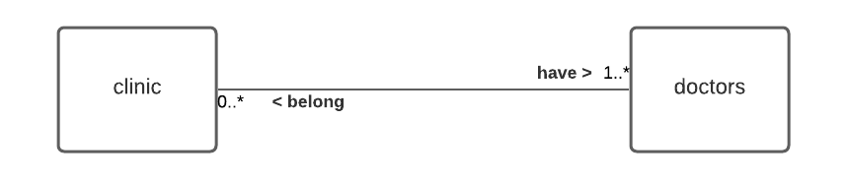

(0.5 points) 1B: A patient may visit one or more doctors; A doctor may take one or more patients.

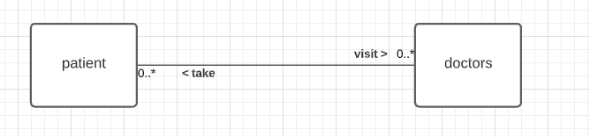

(0.5 points) 1C: A doctor may have one and only one assistant nurse; An assistant nurse must work for one or more doctors.

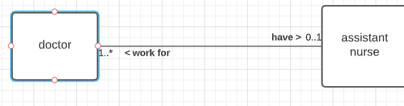

(0.5 points) 1D: A patient must have one and only one history record; A record must belong to one and only one patient.

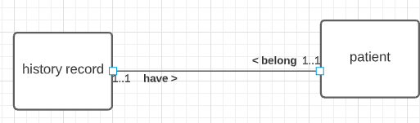

(1 points) 1E: Combine 1A-1D to create the complete ERD. Make sure to add a text box to include the name of ERD – Clinic Database, your name as the author, create/update time, etc.

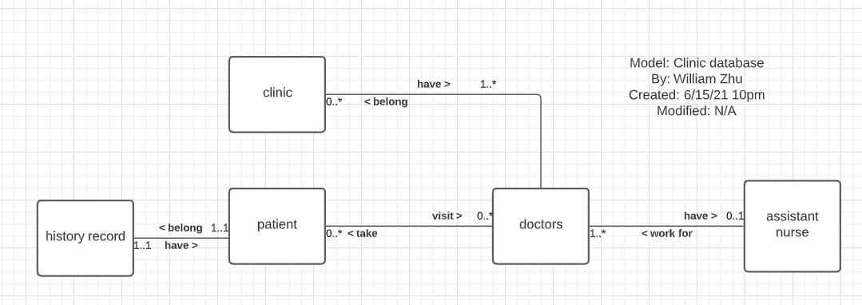

(4 points) Question 2: Read the following statements about a Database for Art Galleries and collection of drawings. Draw the Entity Relationship Attribute Diagram with UML notation. No credit will be granted for other notations. Make sure you have all entities, all attributes (and identifiers), all relationships, and proper multiplicities.

* A gallery must have one and only one location and each location must have one and only one gallery. Galleries have attributes: *GalleryNum(identifier), Name, Phone, Hours, Intro.*

Locations have attributes: *Country, State, City, Street, Zipcode.*

* A gallery may have one or more drawings and each drawing may belong to one and only one gallery.

Drawings have attributes: *DrawingNum(identifier), Title, Size, Material, Date.*

* A drawing must be created by at least one artist and each artist must create at least one drawing.

Artists have attributes: *ArtistNum(identifier), Name, Phone, Birthday, Email.*

* An artist may have a bio statement and a bio statement must belong to one artist.

BioStatements have attributes: *Citizenship, Education, Experience, MasterPiece(s), BriefIntroduction.*

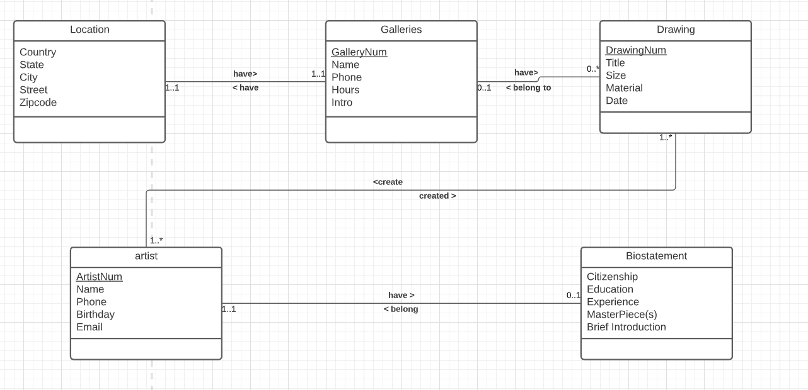

Question 3: Read the following ERD and answer the questions.

(1 point) 3A: What are the entities in the ERD?

Cars, Payment records and Drivers are entities in the ERD.

(2 points) 3B: Translate this ERD to a list of statements. Make sure you address the multiplicities using correct terms may, must, one and only one, one or more, etc.

Drivers must have to one and only one payment records. Payment records must belong to one and only one driver.

Drivers may operate(s) one and only one car. Cars may be operated by one and only one driver.

Drivers may have one or more dependents. Dependents must belong to one or more drivers.

Drivers must report to one and only one supervisor. Supervisors must supervise one or more drivers.